[](http://www.google.co.uk/url?sa=i&rct=j&q=&esrc=s&source=images&cd=&cad=rja&uact=8&ved=0ahUKEwiqxs-9xcPXAhUEaRQKHQ3AAgMQjRwIBw&url=http://clipart-library.com/car-driving-clipart.html&psig=AOvVaw0rZwkUziFXH1901QjPbWeb&ust=1510937097849646)

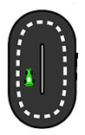

[](http://www.google.co.uk/url?sa=i&rct=j&q=&esrc=s&source=images&cd=&cad=rja&uact=8&ved=0ahUKEwiG-4X9rsPXAhULWRQKHQnIBU8QjRwIBw&url=http://www.freestockphotos.biz/stockphoto/3358&psig=AOvVaw35DkkFWEHubIYecf8RwOdi&ust=1510931041622679)

**Defnyddiwch y cerdiau fflach yma i helpu eich plentyn i gofio sut i ffurfio rhifau. Mae’n bwysig i ailadrodd y rhigymau tro ar ôl tro wrth ffurfio.**

Use the flash cards to help your child to remember how to form numbers. It’s important to repeat the rhymes over and over whilst forming the numbers.

Please try your best to encourage your child to say these in Welsh.

**Parent’s translation (only)**

1. Down as straight as a soldier
2. Over the bridge, down the slide and off for a walk
3. Bump and bump
4. Down, off for a walk and jump straight down
5. Down, big belly and a hat
6. Curl around a yoyo
7. Off for a walk and down the slide
8. The skipping rope goes loop the loop
9. Around the ball then bounce down
10. Down straight like a soldier, the car goes - zeeerooo

I lawr yn syth fel milwr

Mae’r car yn mynd - siiiiro

[](http://www.google.co.uk/url?sa=i&rct=j&q=&esrc=s&source=images&cd=&cad=rja&uact=8&ved=0ahUKEwj1i8Dow8PXAhXBvhQKHUiDDAgQjRwIBw&url=http://eppsnet.com/tag/procrastination/&psig=AOvVaw1bvSLbvh439gC1GGIfzqEx&ust=1510936654003791)

9

Rownd y bêl a’i fownsio



[](http://www.google.co.uk/url?sa=i&rct=j&q=&esrc=s&source=images&cd=&cad=rja&uact=8&ved=0ahUKEwisiojXv8PXAhVG1RQKHThdDR0QjRwIBw&url=http://www.freepngimg.com/png/9042-8-number-png&psig=AOvVaw0qOVusjlL-sGnm3DXGVKPm&ust=1510935506532821)

[](https://www.google.co.uk/url?sa=i&rct=j&q=&esrc=s&source=images&cd=&cad=rja&uact=8&ved=0ahUKEwj5jtykxMPXAhWBnhQKHeKRDmAQjRwIBw&url=https://clipartxtras.com/categories/view/eb11203d678648fdbf74a33803eb81aac7cf2cfe/bouncing-basketball-clipart.html&psig=AOvVaw3yOA31SSbq0a1wBe7XRCyG&ust=1510936766730971)

[](http://www.google.co.uk/url?sa=i&rct=j&q=&esrc=s&source=images&cd=&cad=rja&uact=8&ved=0ahUKEwjRr_aywMPXAhUBVRoKHf7qAowQjRwIBw&url=http://weclipart.com/skipping%2Brope%2Bclipart&psig=AOvVaw2_Ridvnt6VxjBwKLdaibGz&ust=1510935739223326)

[](https://www.google.co.uk/url?sa=i&rct=j&q=&esrc=s&source=images&cd=&cad=rja&uact=8&ved=0ahUKEwj5jtykxMPXAhWBnhQKHeKRDmAQjRwIBw&url=https://clipartxtras.com/categories/view/eb11203d678648fdbf74a33803eb81aac7cf2cfe/bouncing-basketball-clipart.html&psig=AOvVaw3yOA31SSbq0a1wBe7XRCyG&ust=1510936766730971)

Mae’r rhaff sgipio yn mynd lwp-yti-lwp

[](http://www.google.co.uk/url?sa=i&rct=j&q=&esrc=s&source=images&cd=&cad=rja&uact=8&ved=0ahUKEwju_KzcvsPXAhXFvhQKHT2aBygQjRwIBw&url=http://www.clipartpanda.com/clipart_images/girl-walking-clip-art-11833343&psig=AOvVaw0uBre677tsTtV-xcrqwtS5&ust=1510935284604848)

Mas am dro a lawr y llithren

I lawr fel ioio

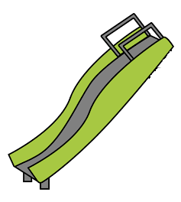

4

I lawr, bola mawr a het

Lawr, mas am dro, neidio a lawr

[](http://www.google.co.uk/url?sa=i&rct=j&q=&esrc=s&source=images&cd=&cad=rja&uact=8&ved=0ahUKEwjbxueSvcPXAhXL8RQKHd8IAfcQjRwIBw&url=http://www.dreamworkstv.com/shows/turbo-fast/&psig=AOvVaw20MWvyIh8VdhcxDP6cS4Sp&ust=1510934862468461)

[](http://www.google.co.uk/url?sa=i&rct=j&q=&esrc=s&source=images&cd=&cad=rja&uact=8&ved=0ahUKEwjey8a-u8PXAhVBKlAKHdv-AgsQjRwIBw&url=http://www.clker.com/clipart-number-5-4.html&psig=AOvVaw3XfUuFcAQjbOMAKvOXrUNf&ust=1510934386318879)

[](http://www.google.co.uk/url?sa=i&rct=j&q=&esrc=s&source=images&cd=&cad=rja&uact=8&ved=0ahUKEwiG-4X9rsPXAhULWRQKHQnIBU8QjRwIBw&url=http://www.freestockphotos.biz/stockphoto/3358&psig=AOvVaw35DkkFWEHubIYecf8RwOdi&ust=1510931041622679)

[](http://www.google.co.uk/url?sa=i&rct=j&q=&esrc=s&source=images&cd=&cad=rja&uact=8&ved=0ahUKEwju_KzcvsPXAhXFvhQKHT2aBygQjRwIBw&url=http://www.clipartpanda.com/clipart_images/girl-walking-clip-art-11833343&psig=AOvVaw0uBre677tsTtV-xcrqwtS5&ust=1510935284604848)

I lawr yn syth fel milwr

Mae’r car yn mynd - siliiiro

Bwmp-yti-bwmp

[](https://www.google.co.uk/url?sa=i&rct=j&q=&esrc=s&source=images&cd=&ved=0ahUKEwiPg5GBt8PXAhWBtxQKHSSLCCkQjRwIBw&url=https://www.mycutegraphics.com/graphics/number/cartoon-number-three.html&psig=AOvVaw0TmJYS6kEu6yhvO3I2I6zm&ust=1510933195954143)[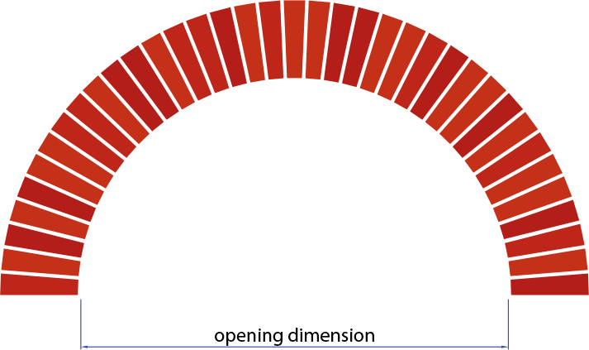](http://www.google.co.uk/url?sa=i&rct=j&q=&esrc=s&source=images&cd=&cad=rja&uact=8&ved=0ahUKEwiBg-jbscPXAhUF1xoKHZHXA8wQjRwIBw&url=http://www.brickfab.com/product/prefabricated-arches/&psig=AOvVaw1Jay2eztceEDHxmeqmch82&ust=1510931783731409)

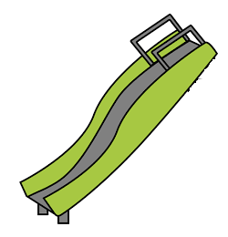

[](http://www.google.co.uk/url?sa=i&rct=j&q=&esrc=s&source=images&cd=&cad=rja&uact=8&ved=0ahUKEwi96pTStsPXAhXCuhQKHRQWAZ8QjRwIBw&url=http://www.clipartpanda.com/categories/children-walking-clip-art&psig=AOvVaw3UPUGPTLT3Nv6SmGQbQ44P&ust=1510933083498827)

Dros y bont, lawr y llithren a mas am dro

[](http://www.google.co.uk/url?sa=i&rct=j&q=&esrc=s&source=images&cd=&cad=rja&uact=8&ved=0ahUKEwiqxs-9xcPXAhUEaRQKHQ3AAgMQjRwIBw&url=http://clipart-library.com/car-driving-clipart.html&psig=AOvVaw0rZwkUziFXH1901QjPbWeb&ust=1510937097849646)[](http://www.google.co.uk/url?sa=i&rct=j&q=&esrc=s&source=images&cd=&cad=rja&uact=8&ved=0ahUKEwiG-4X9rsPXAhULWRQKHQnIBU8QjRwIBw&url=http://www.freestockphotos.biz/stockphoto/3358&psig=AOvVaw35DkkFWEHubIYecf8RwOdi&ust=1510931041622679)

I lawr yn syth fel milwr

Mae’r car yn mynd - siiiiro