Dysgu o bell/ Home learning Melangell 8/3/23
Iaith/Language | Mathemateg/Mathematics | Theme/Thema
Rhymes and Songs  Click on the play button to sing along with Mrs Monico  Letter formation  Please practice forming your letters correctly. You could do this anywhere using different ways e.g. shaving foam, in the snow, coloured pens, crayons….  Please scan the QR codes with your phone or i-pads (in the language ffile on Hwb) You could also copy this link to the direct website.  https://www.youtube.com/watch?v=JX_30xS7dVE&list=PLiKJf8nnSuDu54DKRy8QUpovKrvQ9nY8V  Rhigymau a Chaneuon  Cliciwch ar y botwm chwarae i ganu gyda Mrs Monico  Ffurfio llythyrau  Ymarferwch ffurfio eich llythyrau yn gywir. Gallech wneud hyn unrhyw le gan ddefnyddio gwahanol ffyrdd e.e. ewyn eillio, yn yr eira, beiros lliw, creonau….  Sganiwch y codau QR (sydd ar dudalen Hwb) gyda'ch ffôn neu i-pads. Gallech hefyd gopïo'r ddolen hon i'r wefan uniongyrchol.  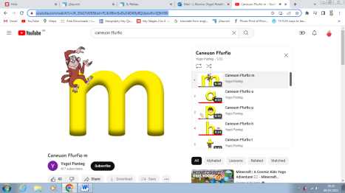 | Number formation  Practice forming your numbers is equally as important. Please use the ‘Number formation rhymes’ to help during the activity as this will help with memory. In class we are currently concentrating on the numbers 2 and 5.  Ffurfio rhifau  Mae ymarfer ffurfio eich rhifau yr un mor bwysig. Defnyddiwch y ‘rhigymau ffurfio rhif’ i helpu yn ystod y gweithgaredd gan y bydd hyn yn helpu gyda’r cof. Yn y dosbarth rydym ar hyn o bryd yn canolbwyntio ar y rhifau 2 a 5.  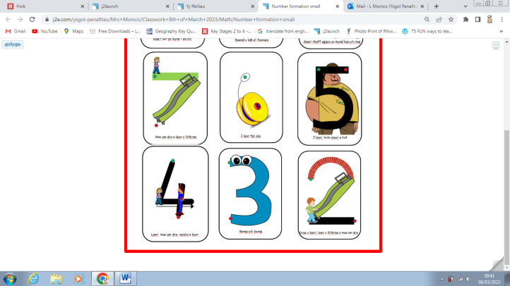  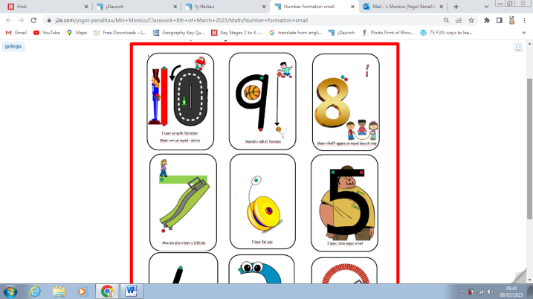 | Creative/Creadigol  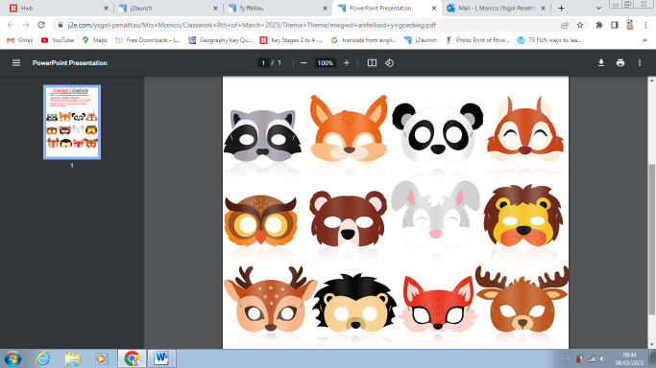  Why not try and make your own forest animal mask. You could use anything around the home i.e. paper, card, cereal boxes, newspaper, magazines  Beth am geisio gwneud eich mwgwd anifail coedwig eich hun. Fe allech chi ddefnyddio unrhyw beth o gwmpas yr hone h.y. bocsys grawnfwyd, papur newydd, cylchgronau

