Dydd Mercher yr 8fed o fis Mawrth Wednesday the 8th of March

Dosbarth Branwen

Iaith | Maths | Thema
ENGLISH  Tasg Darllen - Marcus Rashford (casglwch ffeithiau / collect facts)  Iaith - 1) English Uplevel the sentences (improve them by including adjectives / similes / metaphors ect.)  2) Persuasive writing - Persuasive writing - make notes on the topics and chose one to write about. Persuade the reader that your idea is correct.  For example - Mobile phones are dangerous. Persuade me that they are, or are not.  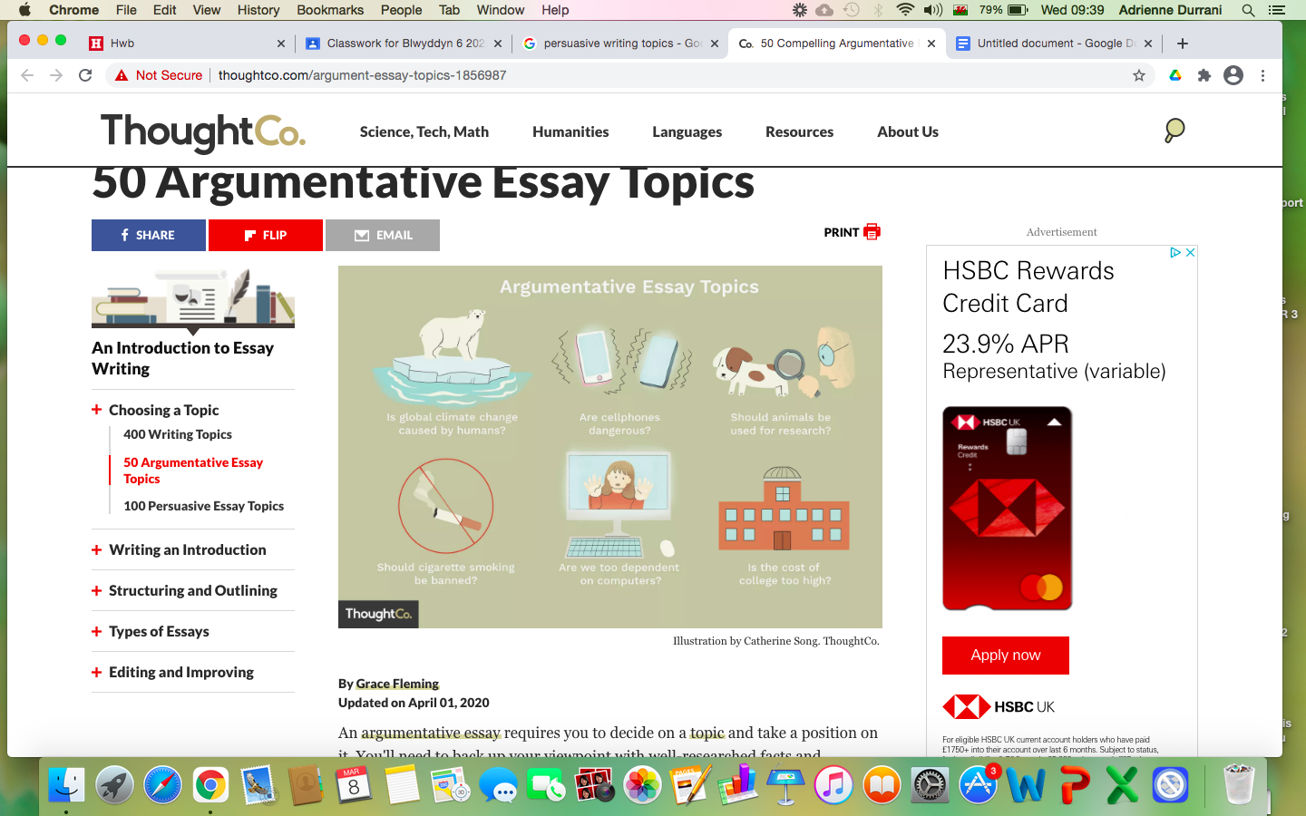 | Maths - Jigso adio gan ddefnyddio dulliau adio gwahanol  Addition  Defnyddiwch llawlyfr Ysgol Gyfun Cwm Rhymni ar gyfer dulliau.  Use the Handook from Ysgol Gyfun Cwm Rhymni for ideas on methods  Dyblu rhifau  Doubling numbers  Wordwall Maths – Online activity  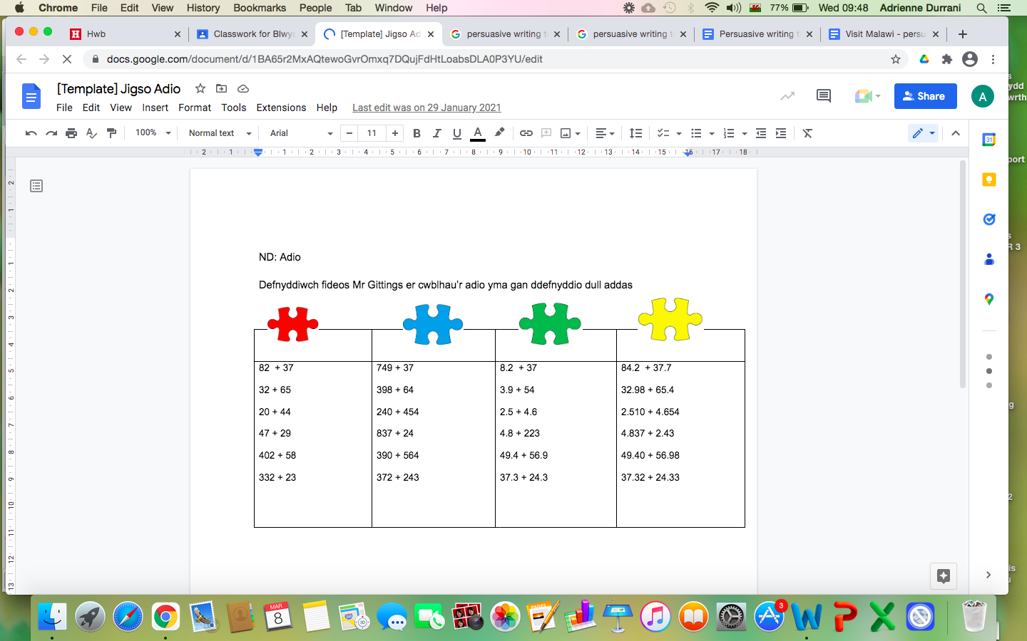 | Thema - Persuade me to travel to Malawi. Why should I visit? Maybe create a poster / PowerPoint to advertise the country too  