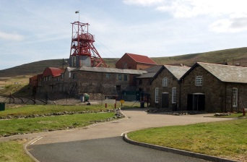****

**Gwibdaith Big Pit Trip**

**I gyd fynd a’n thema dosbarth o Newid, rydym wedi trefnu ymweliad â Big Pit fel ddechreubwynt i’n gwaith ar hanes y diwydiant glo a’i heffaith ar Gymru. Bydd y trip ar Ddydd Mercher, 21ain o fis Chwefror.**

**Gofynnwn yn garedig am gyfraniad o £6.70 tuag at gost y bws. Bydd angen gwisg ysgol, a dillad allanol addas i’r tywydd a brechdanau.**

**A wnewch chi lenwi’r bonyn isod a’i ddychwelyd i’r ysgol gyda’r arian erbyn dydd Gwener 09/02/2024 os gwelwch yn dda?   
Cysylltwch gyda’r ysgol os oes unrhyw gwestiynau**.

As our class theme work is based on Changes, we have arranged a trip to Big Pit as an introduction to our work on the coal industry and its effects on Wales. The trip will be on Wednesday, February 21st.

We kindly ask for a contribution of £6.70 towards the cost of the bus. Pupils are required to wear school uniform on the day. They will also need weather appropriate outerwear and a packed lunch.

Please complete the slip below and return to school with payment by Friday 09/02/2024.   
Please contact the school if you have any questions.

**Gwibdaith Big Pit Trip**

**Enw Plentyn***/ Child’s name_____________________________________________*

**Dosbarth***/ Class: _________________________________________________*

*Amgaeaf* / **I enclose** £6.70

*Llofnod* / **Signed**: ________________________________________________