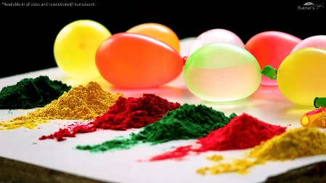

**Tasg:**

* Creu poster gan ateb y cwestiynau canlynol:
* Create a poster by answering the questions below:

1. Beth yw *‘crefydd’*? / What is ‘*religion*’?
2. Beth yw ‘*dathliad Holi’* a sut mae’n cael ei ddathlu o gwmpas y byd ac yng Nghymru? / What is ‘*The Holi Festival’* and how is it celebrated around the world and in Wales?

* Cofiwch / Remember:

1. Creu poster lliwgar llawn ffeithiau i ddal sylw’r darllenwr. Make the poster colourful and full of facts to draw the reader in.
2. Defnyddiwch y wê ar wybodaeth rydych wedi dysgu i’ch helpu.

Use the internet and the information that you have learnt in lessons to help you.

Edrychaf ymlaen i weld eich gwaith ffantastig chi!

I look forward to seeing your excellent work! Bant a chi!

**Tasg Thema: Gwyl ac Ymprydio**