In order to access the resources that are available from the school you will need to log onto your hwb account <https://hwb.gov.wales/>

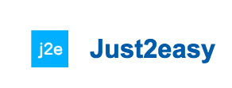

Then go on and choose

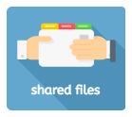

Following this go on

Open the document you wish to complete by clicking ‘edit’ then make sure you save the document to your personal folder. You can then complete the work by typing. The class teacher will be able to gain access to the work and also give feedback.

For example;

How to save your work

How to insert pictures

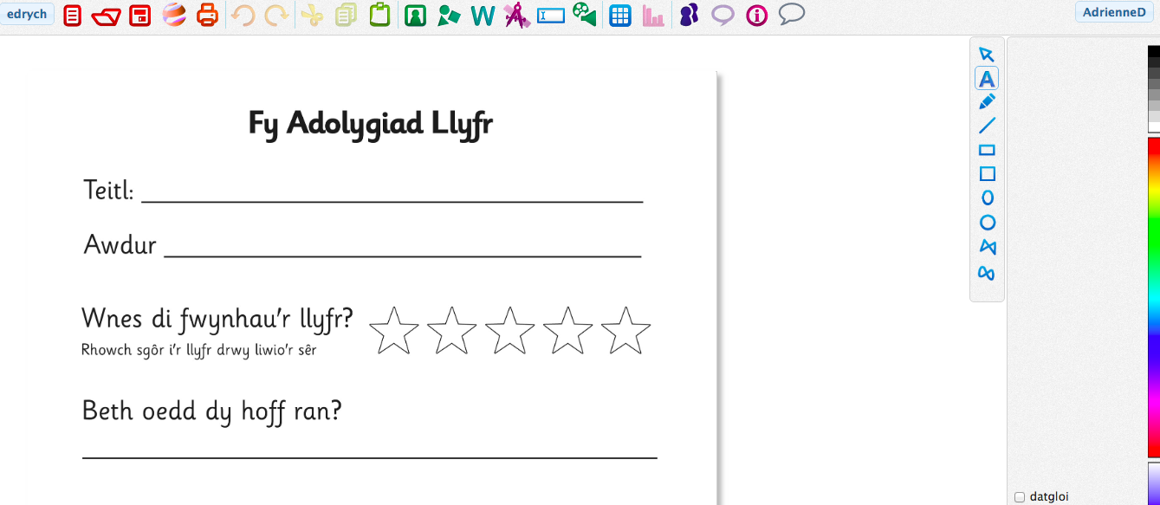

How to type

Your login details:

Er mwyn cael mynediad i’r adnoddau sydd ar gael gan yr ysgol bydd angen mewngofnodi ar hwb <https://hwb.gov.wales/>

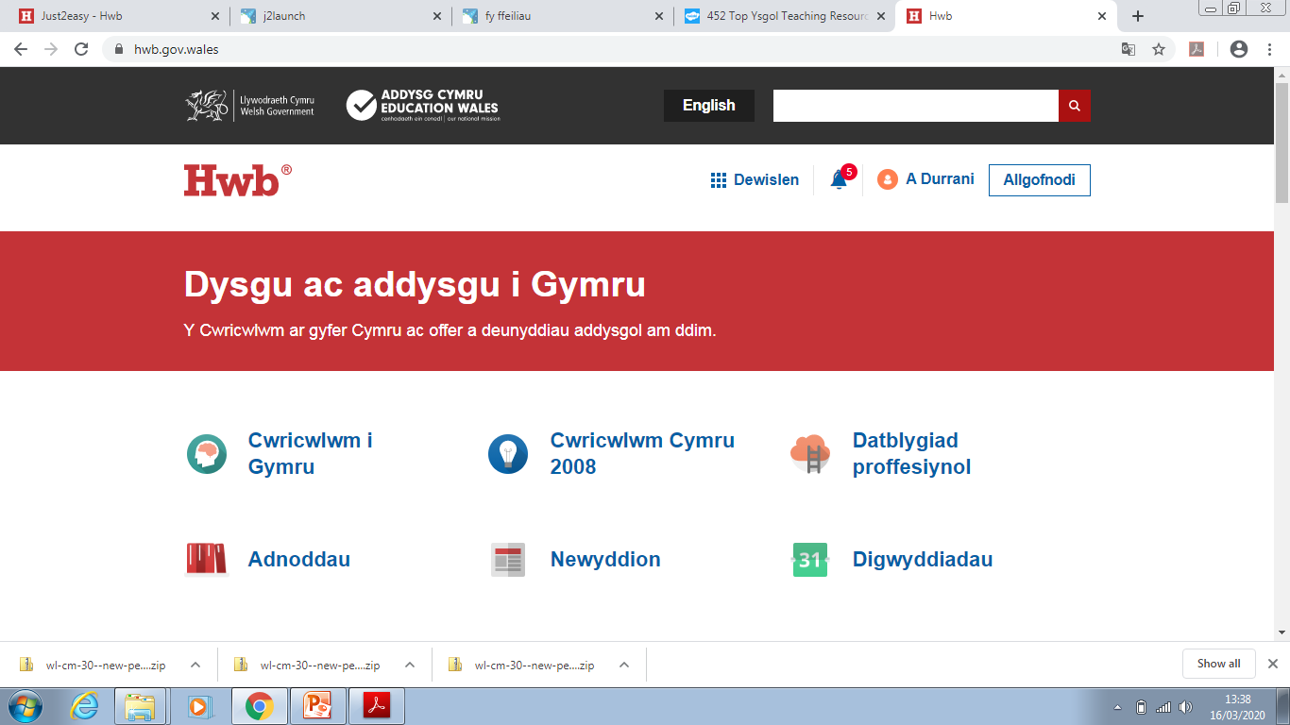

Yna ewch ar a dewiswch

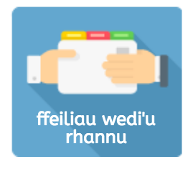

Wedyn ewch ar

Agorwch y ddogfen rydych am gwblhau gan glicio ‘golygu’ ac yna gwnewch yn siwr eich bod chi’n arbed y ddogfen yn eich ffolder personol. Rydych chi wedyn yn gallu cwblhau y gwaith gan ateb cwestiynau drwy deipio. Bydd yr athrawon dosbarth yn gallu cael mynediad i’r gwaith a rhoi adborth.

Er enghraifft:

Sut i arbed eich gwaith

Sut i fewnosod lluniau



Eich manylion mewngofnodi:

Sut i deipio